Midterm I Winter 2019

Data Science for Managers

Due by class: 2/19/2019

Submit an R Markdown for the following two problems. In order to get full credit, your R Markdown document must knit properly.

## Problem 1

Please write code that completes the following:

* Create a new variable for the departure hour from the scheduled departure time variable
* Calculate the number of flights that leave during each hour and each airport
* Draw a bar chart for each of the three New York airports
* Color the bars based on their origin airport
* It is not required that your graph replicate the graph labels. We will cover that in Chapter 28.

flights %>%   
 mutate(  
 dep_hour = sched_dep_time %/% 100  
 ) %>%   
 group_by(origin, dep_hour) %>%  
 summarise(  
 number_flights = n()  
 ) %>%   
 ggplot(aes(dep_hour, number_flights, fill = origin)) +  
 geom_col(show.legend = FALSE) +  
 facet_grid(rows = vars(origin)) +  
 labs(  
 title = "Number of flights leaving each New York airport by departure hour",  
 subtitle = "Departure hour calculated from the scheduled departure time",  
 x = "Departure hour",  
 y = "Total number of flights\n"  
 )

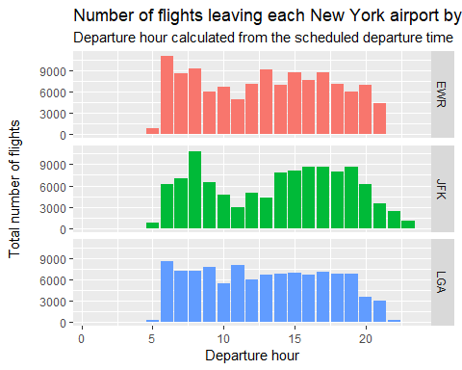

## Problem 2

Please write code that completes the following:

* Determine the number of destinations for each NYC airport
* Create a bar chart that depicts the number of destinations
* Color the bars based on the departure airport
* Order the bars from smallest to largest number of destinations (This is called a Pareto Chart)
* It is not required that your graph replicate the graph labels. We will cover that in Chapter 28.

flights %>%   
 group_by(origin) %>%   
 summarise(  
 destinations = n_distinct(dest)  
 ) %>%   
 ggplot(aes(x = reorder(origin, destinations, FUN = sum), y = destinations)) +  
 geom_col(aes(fill = origin), show.legend = FALSE) +  
 labs(  
 title = "Number of distinations for each New York airport",  
 subtitle = "Sorted by number of destinations",  
 x = "New York Airport",  
 y = "Number of Destinations"  
 )

